Assignment#1: Product Roadmap, Release Plan and Story Map
Key
PLease refer to the scenario CRM Sales Managemement software and crearte a prodcut roadmap, release plan and story map in Jira or any othe agile tool.

guidelines to be followed:
- refer to the elevator pitch and understand what are some of the uniq features that the crm innovator product should have.
- define the mvp (minimal viable product)
- come up with release plan post mvp that will add incremental value to the product
- discuss in the team why do you recommend specific features in specific relesase
- understand the different roles and their needs for crm sales and marketing software that the product should fulfill.

prodcut roadmap
The product roadmap created in jira.

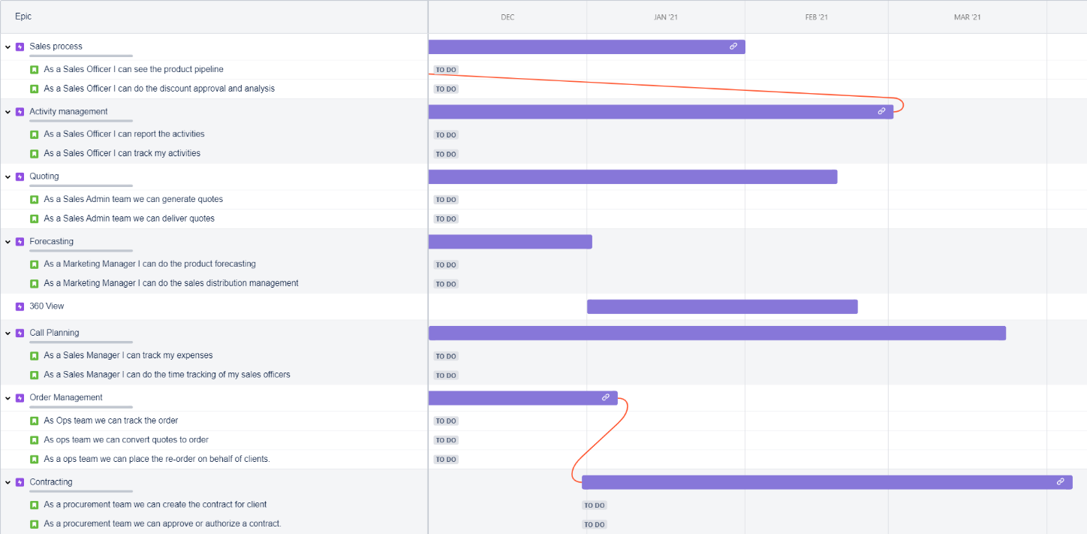

release plan
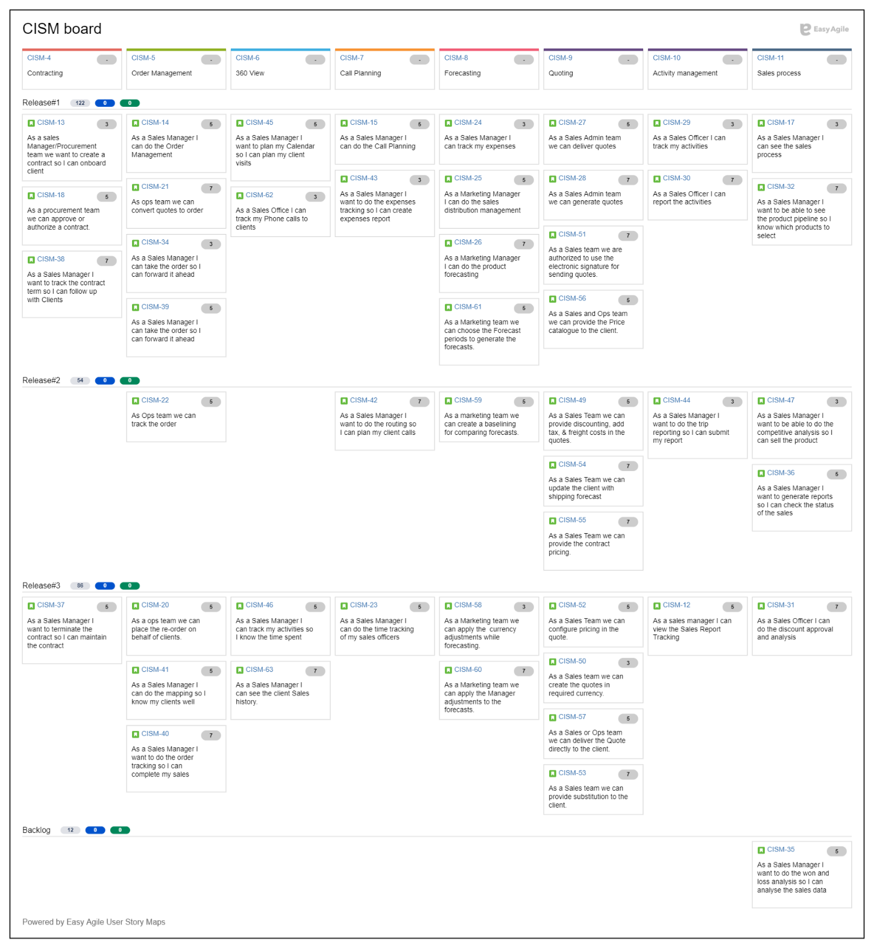

story map

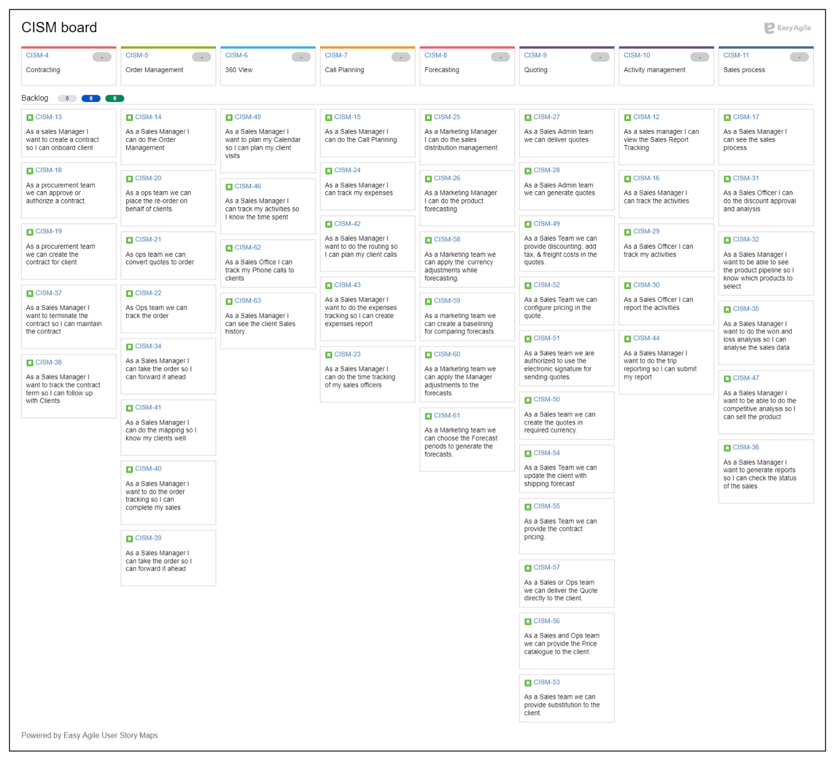

Story map by sprint swimlanes

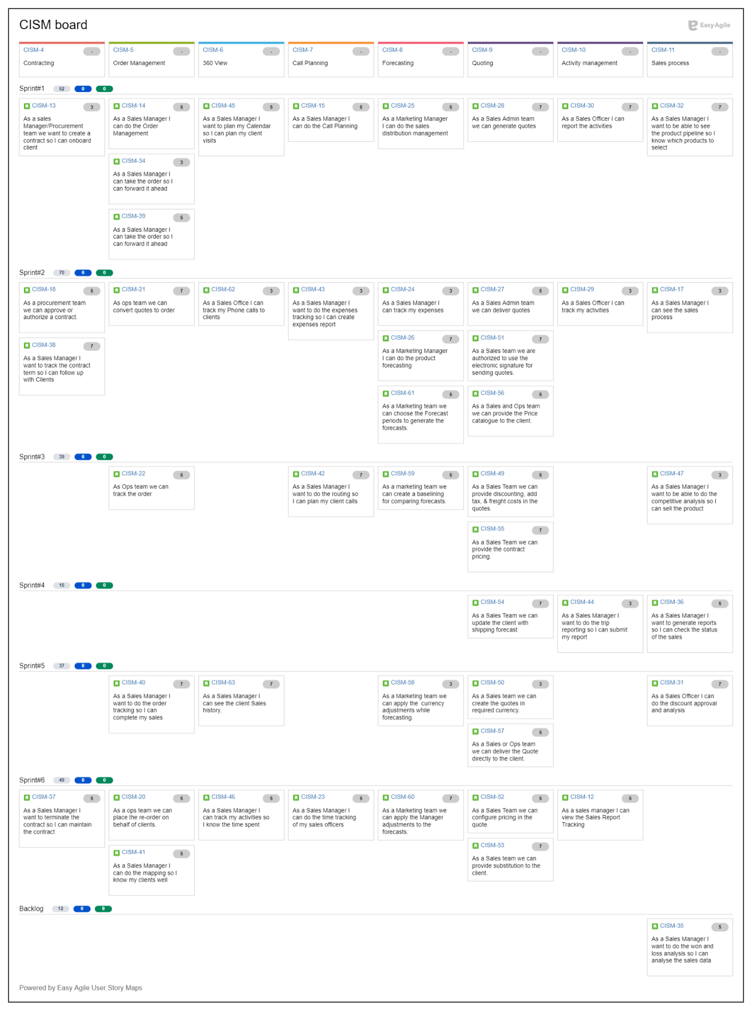

Story map by release/version swimlanes



